Empathize & Discover: Empathy Map Canvas

Parameter | Details
Date | 18 June 2026
Team ID
Project Name | Book A Doctor
Maximum Marks | 4 Marks

____________________________________________________

Empathy Map Canvas:
An empathy map is a simple, easy-to-digest visual that captures knowledge about a user’s behaviours and attitudes.
It is a useful tool to help teams better understand their users.
Creating an effective solution requires understanding the true problem and the person who is experiencing it. The exercise of creating the map helps participants consider things from the user’s perspective along with his or her goals and challenges.

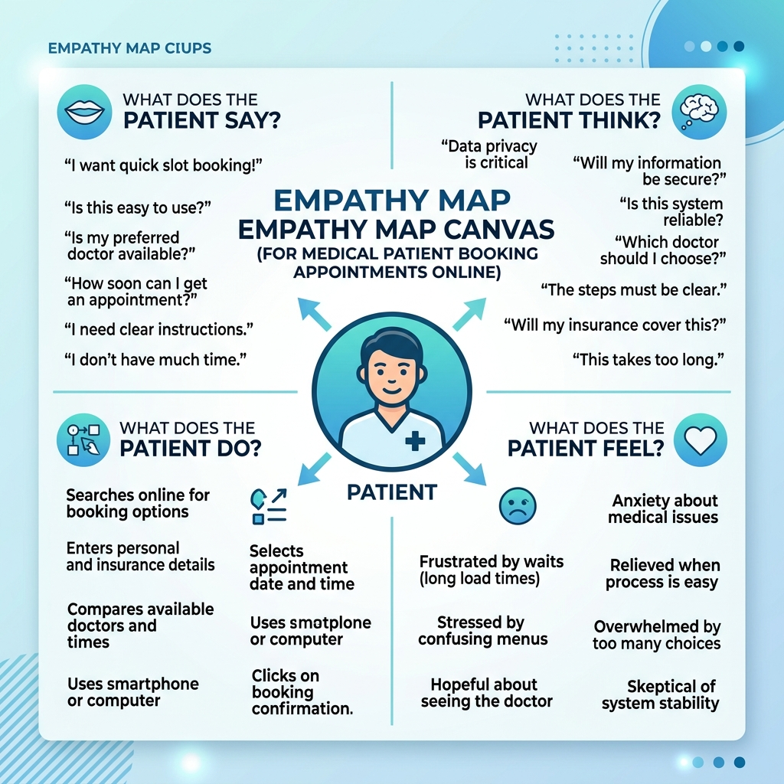
Empathy Map Canvas

Empathy Map 1: The Patient

+--------------------------------------------------------------------------------------------------+
| WHO ARE WE EMPATHIZING WITH? |
| A patient who is feeling unwell or needs a check-up and wants to book a nearby qualified doctor. |
+--------------------------------------------------------------------------------------------------+
| WHAT DO THEY NEED TO DO? |
| Find a specialist, view actual fees & location, see open slot times, book, and upload history. |
+--------------------------------------------------------------------------------------------------+
| WHAT DO THEY SEE? |
| - Complex hospital websites with outdated timetables. |
| - Reviews and ratings online, often conflicting. |
| - Long physical queues at clinic counters. |
+--------------------------------------------------------------------------------------------------+
| WHAT DO THEY HEAR? |
| - Friends complaining about doctor wait times. |
| - Clinic receptionists saying: "We don't have slots open today, try next week." |
| - Tech-savvy peers using instant booking applications. |
+--------------------------------------------------------------------------------------------------+
| WHAT DO THEY SAY & DO? |
| - "Is there a way to book a slot for 10 AM without calling?" |
| - Looks up multiple doctors on Google Search. |
| - Keeps physical copies of medical files, often losing them during visits. |
+--------------------------------------------------------------------------------------------------+
| WHAT DO THEY THINK & FEEL? |
| PAINS: |
| - Fear of not finding a doctor in time. |
| - Privacy concerns regarding medical documents. |
| GAINS: |
| - Wants a transparent appointment slot. |
| - Digital dashboard showing active booking statuses. |
+--------------------------------------------------------------------------------------------------+

Empathy Map 2: The Doctor

+--------------------------------------------------------------------------------------------------+
| WHO ARE WE EMPATHIZING WITH? |
| A busy practitioner who wants to optimize their clinic schedule and view patient records easily. |
+--------------------------------------------------------------------------------------------------+
| WHAT DO THEY NEED TO DO? |
| Define daily slot availability, check incoming patient list, update booking statuses, and view |
| uploaded patient documents. |
+--------------------------------------------------------------------------------------------------+
| WHAT DO THEY SEE? |
| - Gaps in the schedule when patients do not show up without canceling. |
| - Overcrowded waiting rooms during peak hours. |
| - Disorganized physical folders of patient histories. |
+--------------------------------------------------------------------------------------------------+
| WHAT DO THEY HEAR? |
| - Patients complaining about waiting 45 minutes past their slot. |
| - Assistant staff complaining about manual schedule book entry mistakes. |
| - Colleagues using digital dashboard calendars to run clinics. |
+--------------------------------------------------------------------------------------------------+
| WHAT DO THEY SAY & DO? |
| - "I want to start my appointments on time." |
| - Approves/rejects bookings manually by telling the receptionist. |
| - Requests patients to bring their history reports. |
+--------------------------------------------------------------------------------------------------+
| WHAT DO THEY THINK & FEEL? |
| PAINS: |
| - No-shows causing wasted time. |
| - High friction trying to update availability on the fly. |
| GAINS: |
| - Clean schedule visualization. |
| - Patient health records available digitally before the session starts. |
+--------------------------------------------------------------------------------------------------+

